Ref/LOA/RSIL/

I hereby authorize R Systems International through its designated representatives to conduct a comprehensive review of my current and permanent residences, employment history, education background, civil and criminal history records through any designated investigation agency.

I further authorize R Systems International through its representatives to divulge any or all information, in written, pertaining to me to any designated investigative agency.

Candidate's Name: GAURAV GUPTA

Signature: 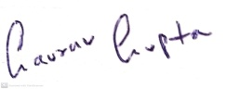

Date:07TH Nov 2022